LIBRARY MANAGEMENT SYSTEM

A Mini Project Report

Submitted by

Hanshika Reddy

Department of Data science

Gayatri Vidya Parishad College of Engineering

Academic Year: 2026–2027

INTRODUCTION

The Library Management System is a relational database project developed using MySQL Workbench. The system is designed to manage essential library operations, including maintaining records of authors, books, members, and borrowing transactions.

The project demonstrates the practical implementation of SQL concepts such as database creation, table creation, primary keys, foreign keys, data insertion, data retrieval, joins, aggregate functions, views, stored procedures, and triggers. The database ensures data integrity through relationships between tables and provides an efficient way to manage library information.

This project serves as a basic database management application and helps understand the practical usage of SQL in real-world scenarios.

ABSTRACT

The Library Management System is a relational database project developed using MySQL Workbench. The system is designed to manage essential library operations, including maintaining records of authors, books, members, and borrowing transactions.

The project demonstrates the practical implementation of SQL concepts such as database creation, table creation, primary keys, foreign keys, data insertion, data retrieval, joins, aggregate functions, views, stored procedures, and triggers. The database ensures data integrity through relationships between tables and provides an efficient way to manage library information.

This project serves as a basic database management application and helps understand the practical usage of SQL in real-world scenarios.

OBJECTIVES

The main objectives of this project are:

• To develop a Library Management System using MySQL.

• To maintain records of authors, books, members, and borrow transactions.

• To perform CRUD (Create, Read, Update, Delete) operations.

• To implement relationships using Primary Keys and Foreign Keys.

• To retrieve information using JOIN queries.

• To perform data analysis using aggregate functions.

• To implement Views, Stored Procedures, and Triggers.

• To maintain data consistency and integrity.

SOFTWARE REQUIREMENTS

The following software and hardware requirements were used to develop the Library Management System.

Software Requirements

• Operating System: Windows 10 / Windows 11

• Database: MySQL 8.0

• Database Tool: MySQL Workbench

• Programming Language: SQL

• Documentation Tool: Google Docs / Microsoft Word

Hardware Requirements

• Processor: Intel Core i3 or above

• RAM: Minimum 4 GB

• Storage: Minimum 500 MB free disk space

• Keyboard and Mouse

• Monitor

DATABASE DESIGN

The Library Management System is designed using a relational database model. The database consists of four tables: Authors, Books, Members, and Borrow.

Each table stores specific information related to library management. Relationships between the tables are established using Primary Keys and Foreign Keys to maintain data consistency.

The database allows efficient storage, retrieval, updating, and management of library records.

ER Diagram

The Entity Relationship (ER) Diagram illustrates the relationship between the database tables used in the Library Management System.

The Authors table is related to the Books table through the Author ID. The Books table and Members table are connected to the Borrow table using foreign key relationships. These relationships ensure data integrity and eliminate redundancy.
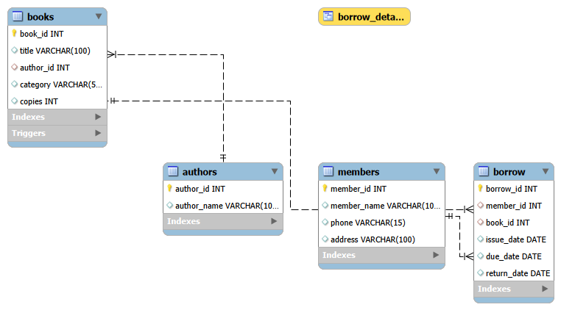

DATABASE TABLES

Authors Table :
The Authors table stores information about authors. Each author has a unique Author ID and Author Name.
Books Table :
The Books table stores book details such as Book ID, Title, Category, Number of Copies, and Author ID.
Members Table :
The Members table stores information about library members, including Member ID, Name, Phone Number, and Address.
Borrow Table :
The Borrow table stores borrowing records. It connects Members and Books through foreign keys and stores Issue Date, Due Date, and Return Date.
SQL QUERIES USED

The following SQL statements were implemented in the project:

• CREATE DATABASE

• CREATE TABLE

• INSERT INTO

• SELECT

• UPDATE

• DELETE

• INNER JOIN

• GROUP BY

• COUNT()

• SUM()

• CREATE VIEW

• CREATE PROCEDURE

• CREATE TRIGGER

These SQL commands were used to create the database structure, insert records, retrieve information, modify data, and implement advanced database features such as views, stored procedures, and triggers.
FEATURES OF THE LIBRARY MANAGEMENT SYSTEM

The Library Management System provides the following features:

• Stores details of authors and books.

• Maintains library member information.

• Records book borrowing transactions.

• Displays book and member information using SQL queries.

• Generates reports using aggregate functions.

• Uses JOIN operations to retrieve related data.

• Implements Views for simplified data access.

• Uses Stored Procedures to execute predefined operations.

• Uses Triggers to prevent invalid data updates.

• Maintains data integrity using Primary Keys and Foreign Keys.

Output Screenshots :

The following screenshots demonstrate the successful implementation and execution of the Library Management System database.

1. Tables Created
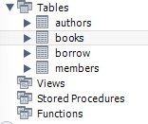
2. Authors Table Data
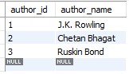
3. Books Table Data

4. Members Table Data
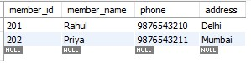
5. Borrow Table Data
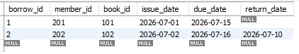
6. JOIN Query Output


7. Stored Procedure Output

8. Trigger Output
Advantages

The Library Management System offers several advantages:

• Reduces manual work by maintaining digital records.

• Ensures data accuracy through Primary Key and Foreign Key constraints.

• Allows quick retrieval of information using SQL queries.

• Prevents duplicate and inconsistent records.

• Supports efficient book borrowing and return management.

• Provides easy report generation using SQL aggregate functions.

• Demonstrates advanced SQL concepts such as Views, Stored Procedures, and Triggers.

• Can be easily expanded with additional features in the future.

CONCLUSION

The Library Management System project successfully demonstrates the implementation of a relational database using MySQL Workbench.

The project includes the creation of tables, insertion of records, retrieval of information through SQL queries, implementation of relationships using Primary Keys and Foreign Keys, and the use of advanced SQL features such as Views, Stored Procedures, and Triggers.

This project provides a practical understanding of database management concepts and serves as a strong foundation for developing larger database-driven applications.

FUTURE ENHANCEMENTS

The Library Management System can be enhanced in several ways:

• Develop a graphical user interface (GUI).

• Add user authentication and login functionality.

• Generate reports in PDF format.

• Implement fine calculation for overdue books.

• Add book reservation and renewal features.

• Integrate barcode or QR code scanning.

• Store book cover images.

• Connect the database with a web or mobile application.

• Implement cloud-based database storage.

These enhancements would make the system more user-friendly and suitable for real-world library management.

REFERENCES

1. MySQL 8.0 Documentation
2. MySQL Workbench Documentation
3. SQL Tutorial – W3Schools
4. SQLBolt
5. Course Notes and Laboratory Manual

